Combustion Reaction!

## Combustion of gasoline to power your car:

**Reactants Products**

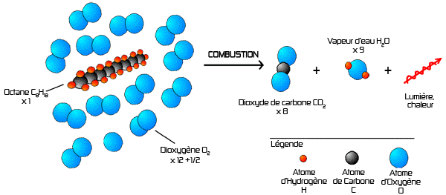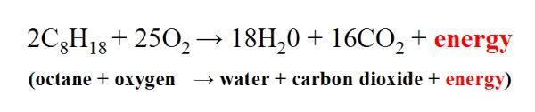

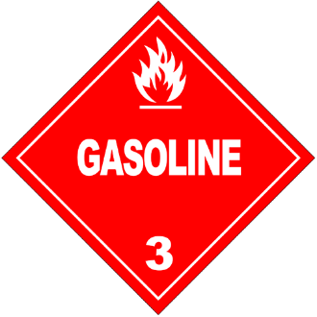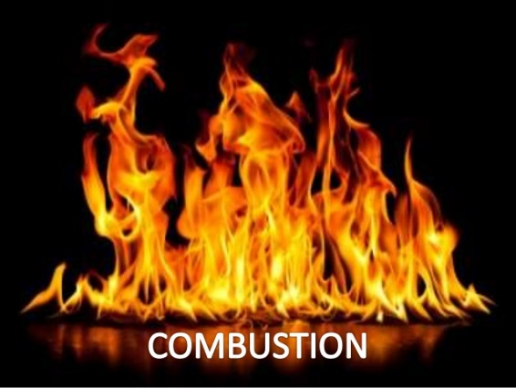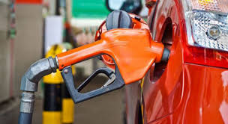

The combustion of gasoline combines octane, C8H18, with oxygen gas, O2. When the two react, the products are water, H2O, and carbon dioxide, CO2. In this reaction, energy is released. This energy is what is used to power a car’s engine.